CS 255 System Design Document

UML Diagrams

UML Use Case Diagram
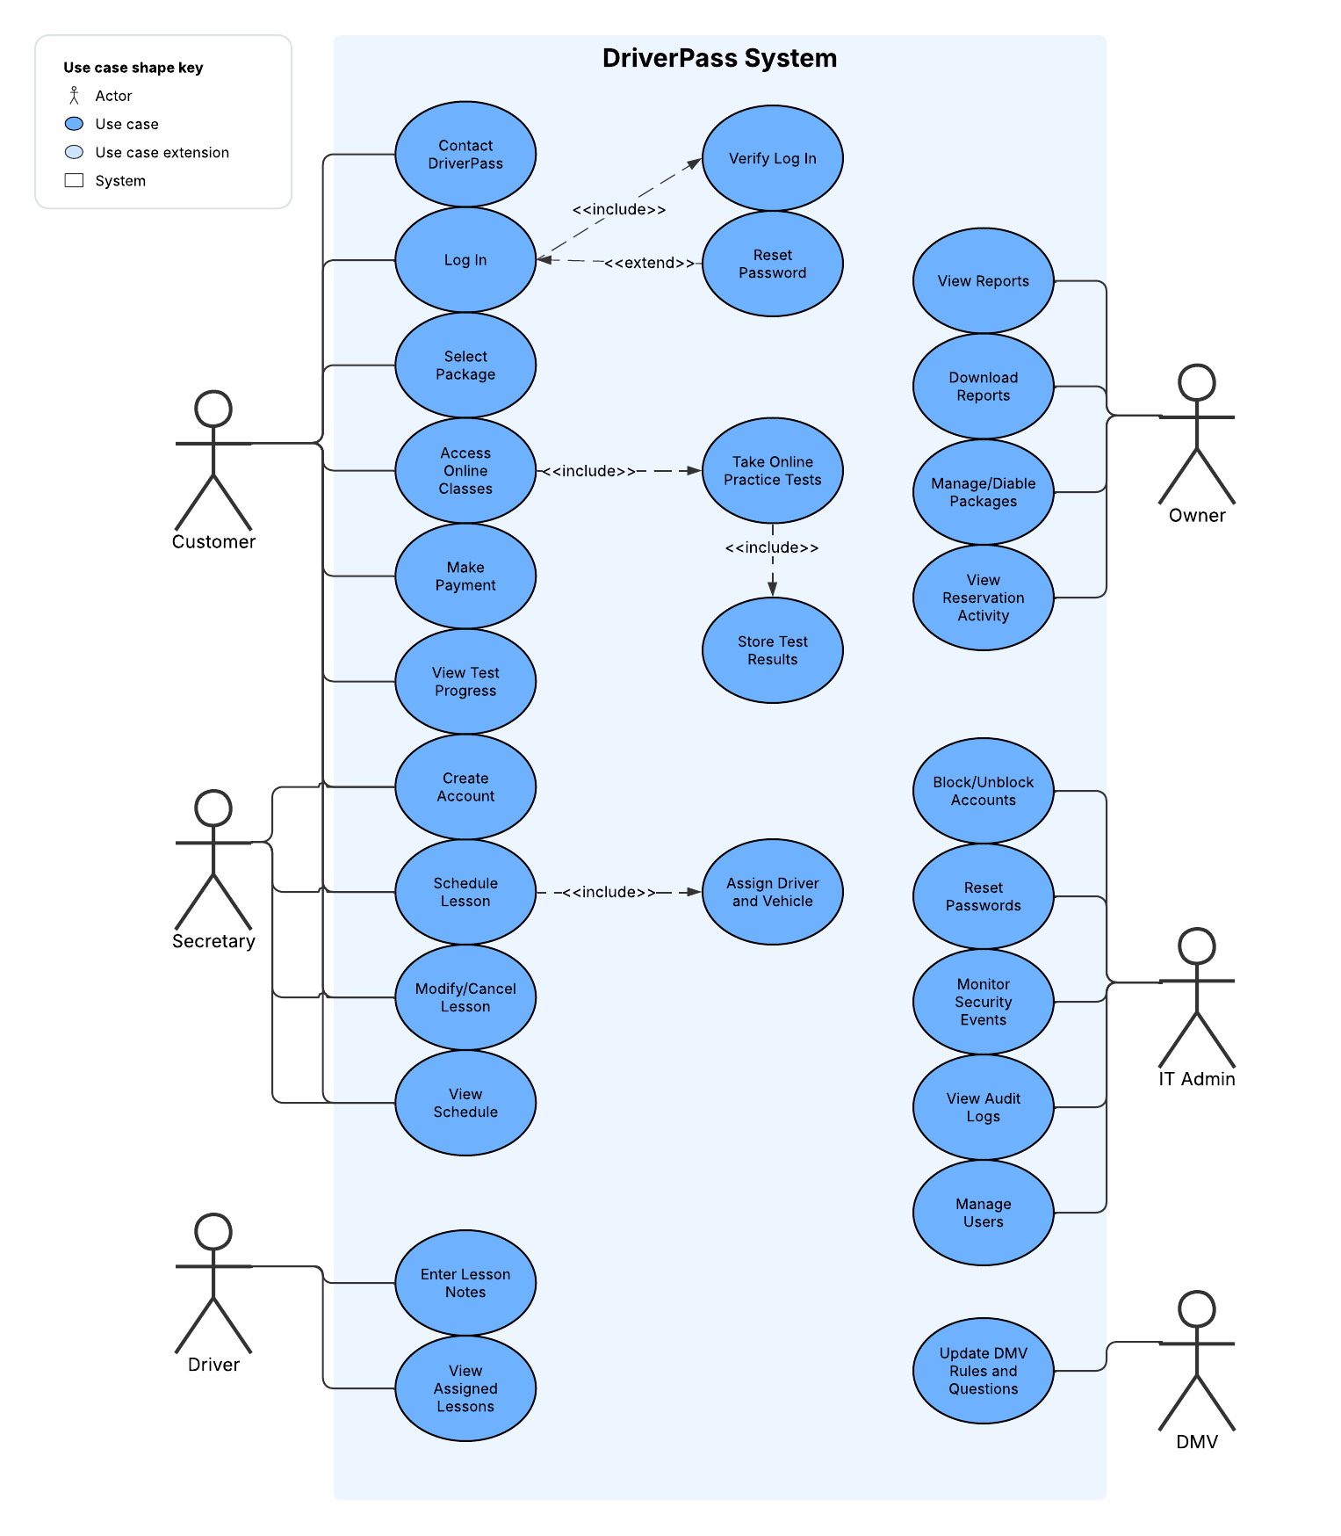

UML Activity Diagrams
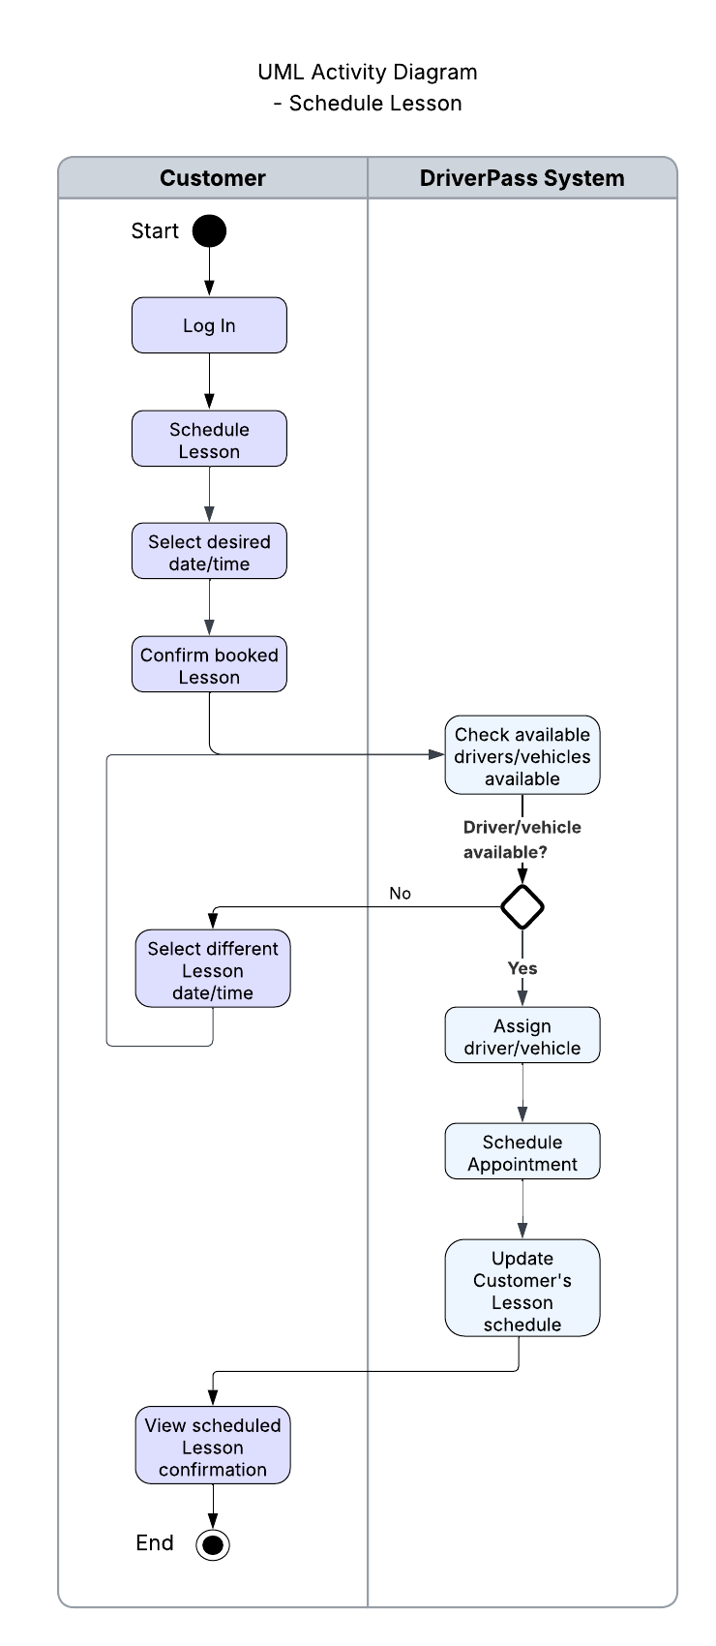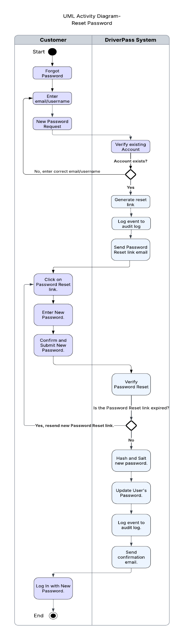

UML Sequence Diagram
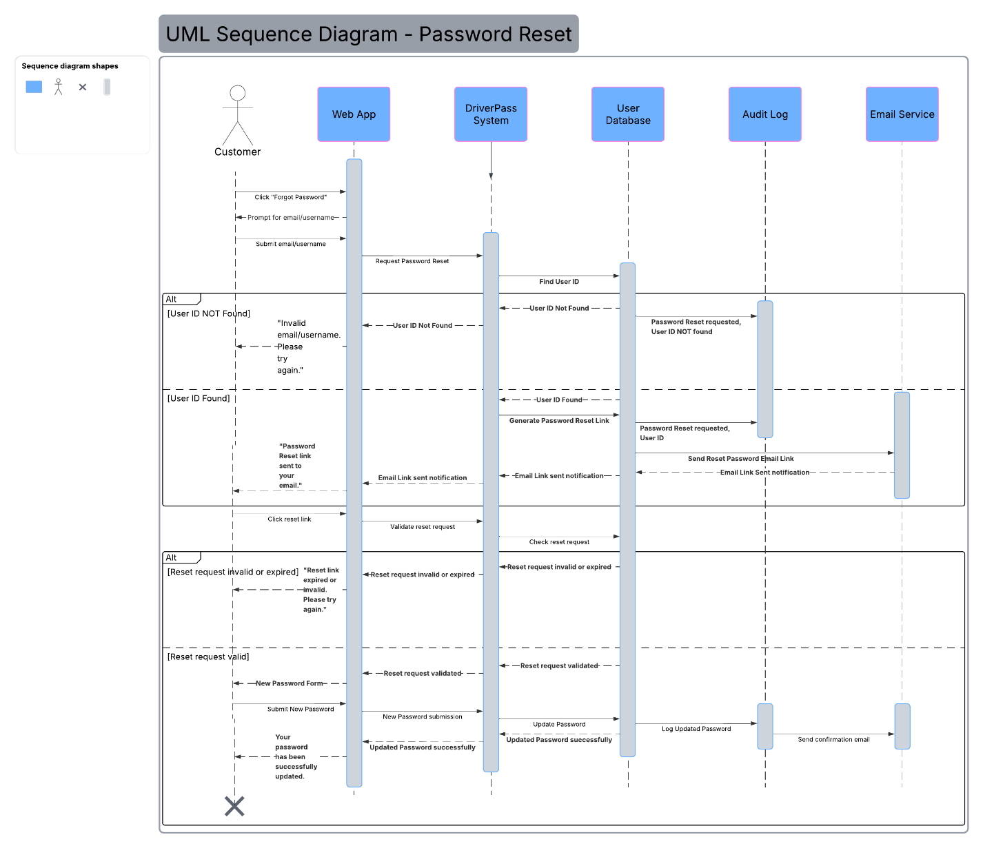

UML Class Diagram
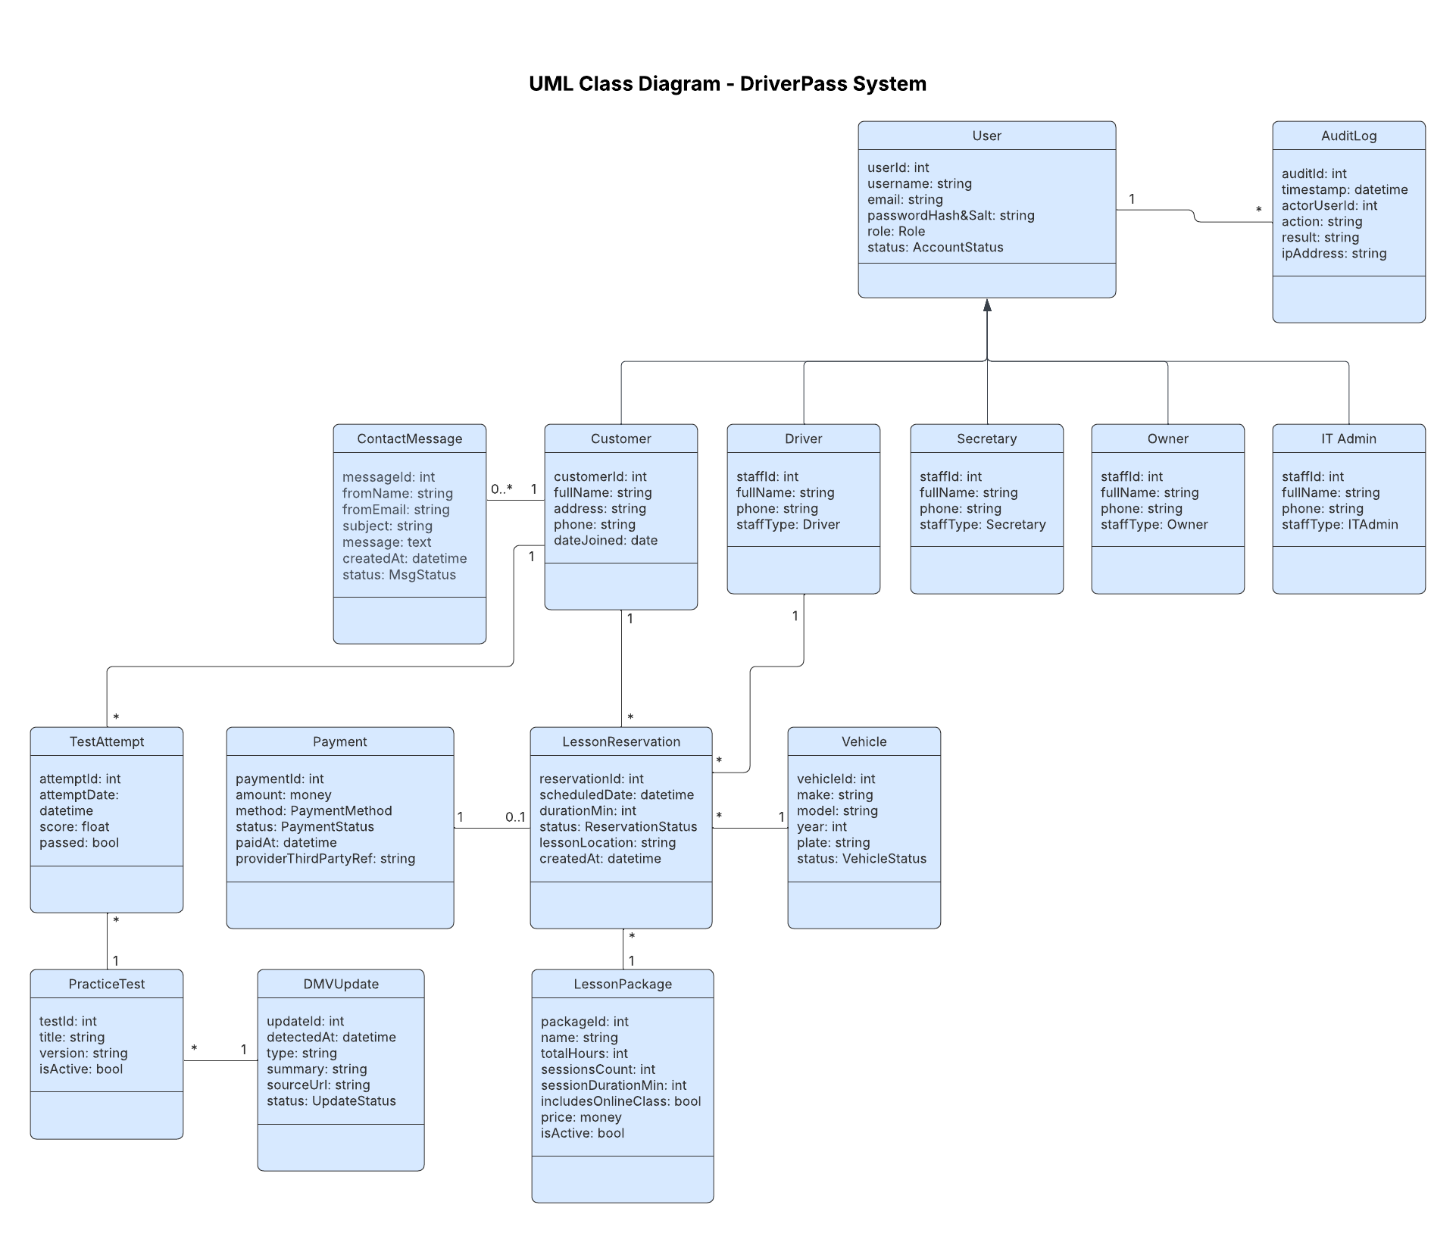

Technical Requirements
Hardware Requirements
- The system shall allow users to access the application using a desktop, laptop, or mobile device with internet connectivity, and capable of running web browsers efficiently.
- The system shall be hosted on cloud-based servers with sufficient resources to efficiently handle multiple users at the same time.
- The system shall support scalable server for increased user demand without slowing down.

Software Requirements
- The system shall operate as a web-based application accessible on modern browsers and supported across Windows, macOS, iOS, and Android.
- The system shall use a server-side RESTful API and a relational database to manage and store data.
- The system shall enforce role-based access and securely store user credentials using hashed and salted passwords.
- The system shall generate and export Excel-compatible reports.

Tool Requirements
- The system shall log, monitor and alert system activities, errors, payments, login attempts, and scheduling conflicts.
- The system shall use email services for notifications and third-party payment processors for secure transactions.
- The system shall use an automatic mechanism to check for and update DMV information daily.

Infrastructure Requirements
- The system shall be cloud-hosted, internet-accessible, and use HTTPS/TLS for secure communication.
- The system shall store sensitive data, and support separate environments, for development and testing.
- The system shall support automatic backups, recovery processes, and high availability with little to no downtime.

